**Case Study**

*Module 5: Configuration Management with Ansible*

Steps for setting up Apache Tomcat using ansible

**Goal** - Provision the production environment for the upcoming update of their software

1. Created 3 amazon instance - ansible controller and 2 node instances

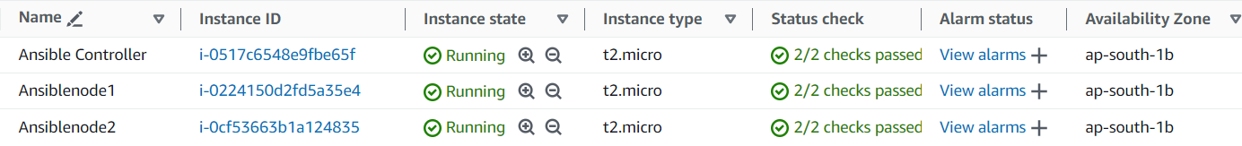

1. Installed ansible on the ansible controller instance

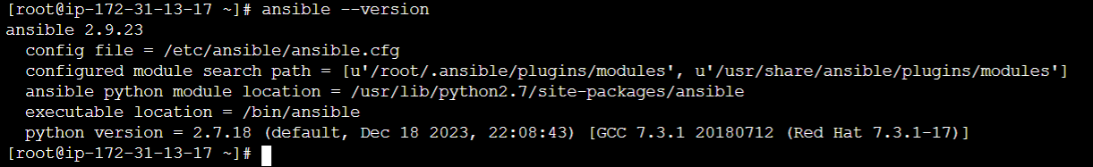

1. Created roles and playbook inside ansible

Commands-

Cd roles

Ansible-galaxy init testrole

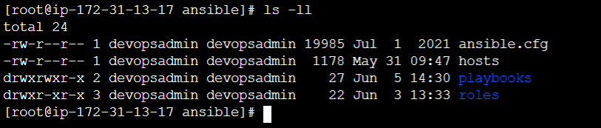

1. Made ssh connection with node 1 & node 2

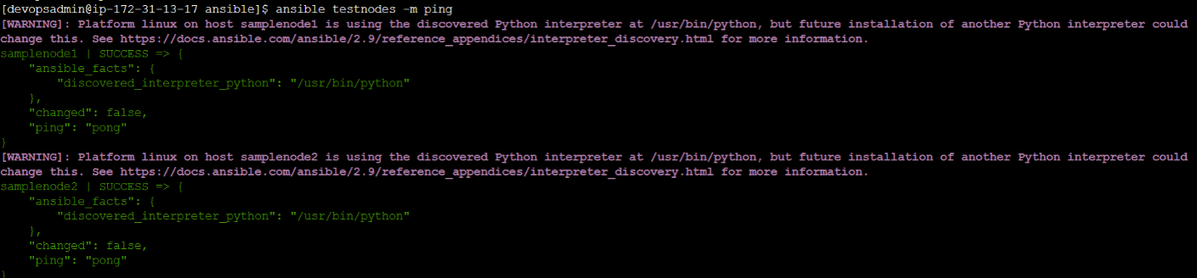

1. Created role named testrole for apache tomcat installation .

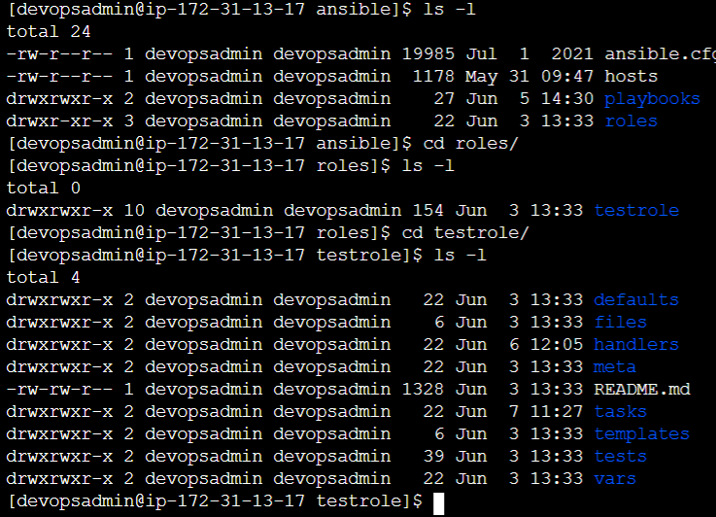

1. Main.yml entry from “task” directory of role name - testrole

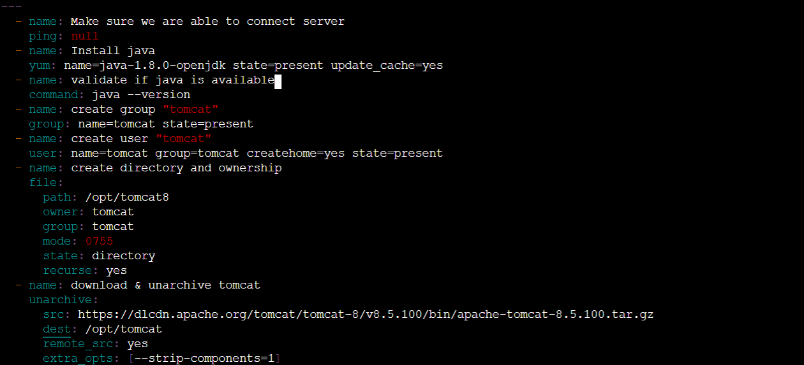

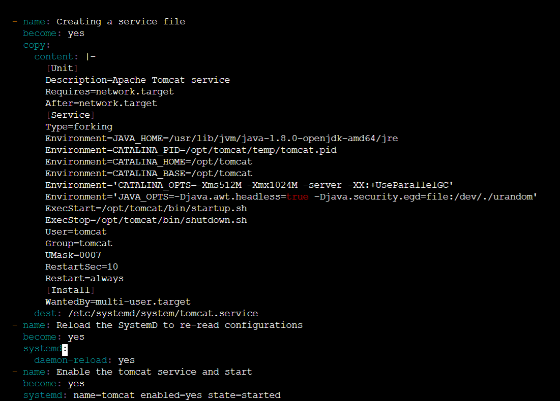

1. “Handlers” entry yaml script

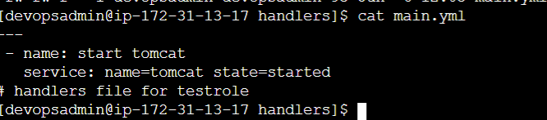

1. Entry inside playbook - rolesdemo.yml

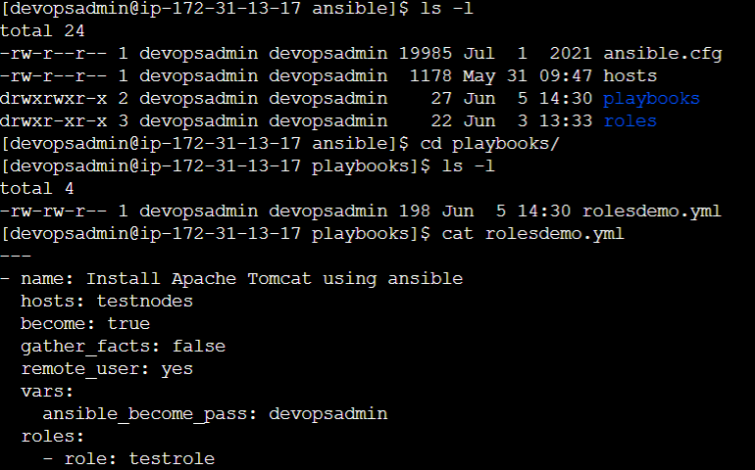

1. Tomcat got installed into node instancers

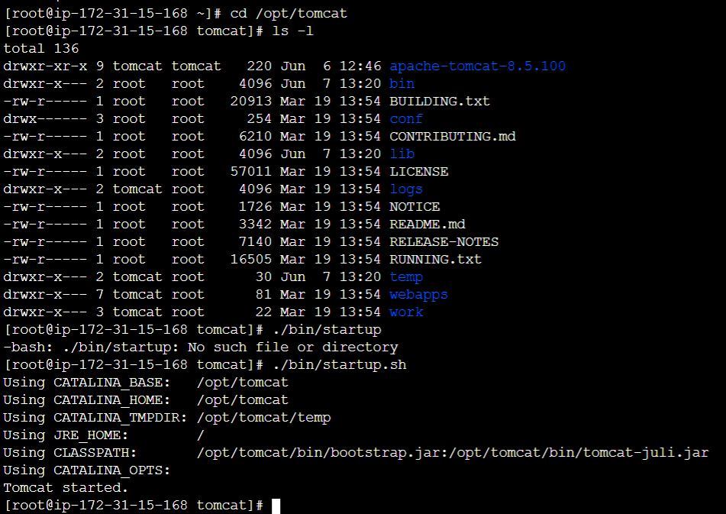

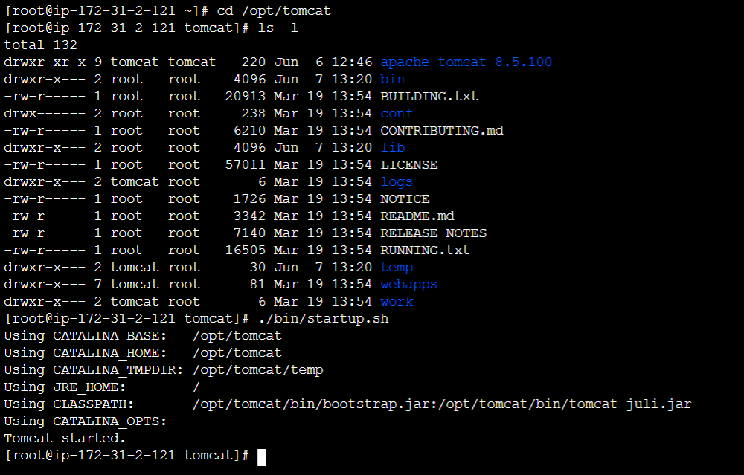

Steps for setting up Apache Maven using ansible

1. Created role for maven installation in ansible controller

cd roles/

ansible-galaxy init mavenrole

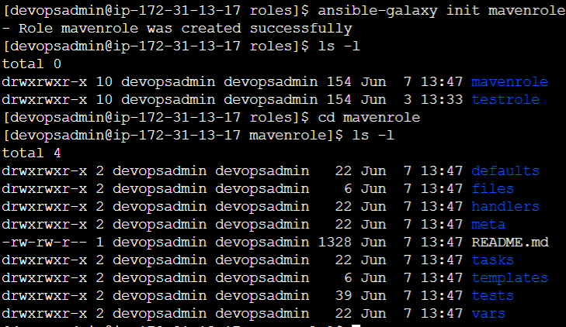

1. Main.yml entry from Task directory

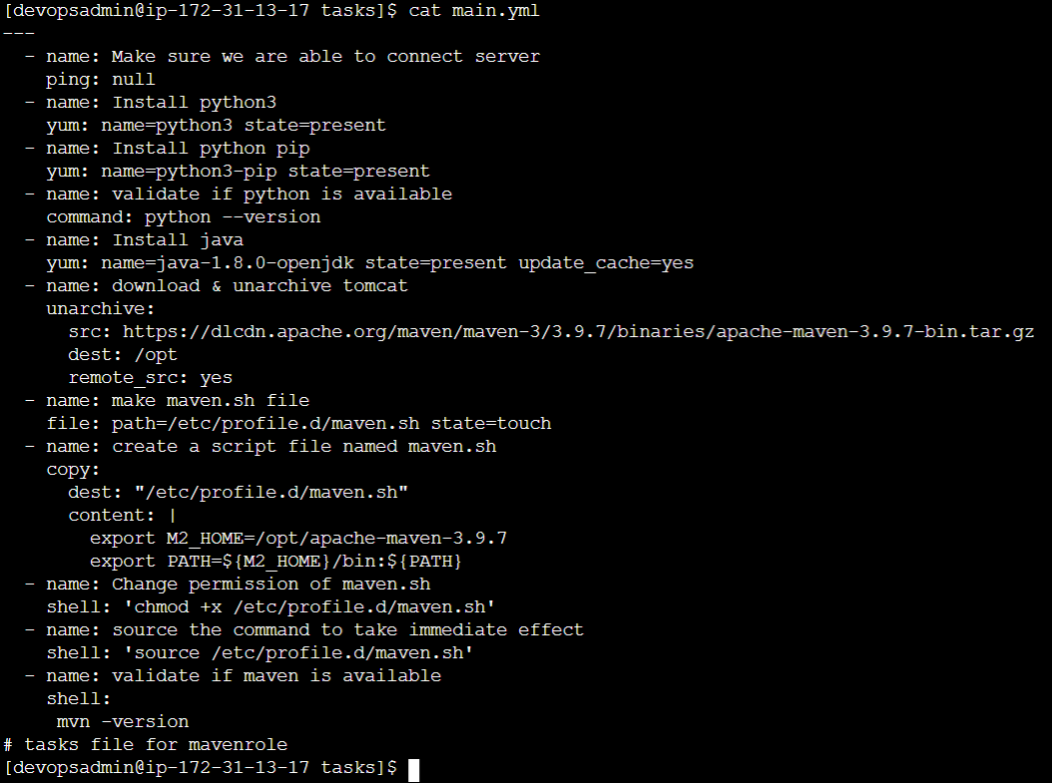

1. Brought both roles into one playbook.

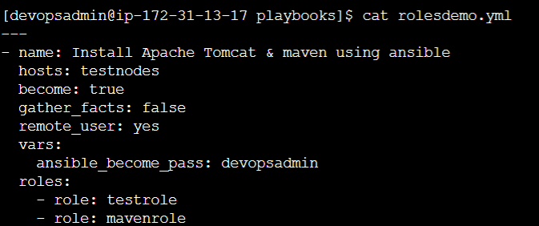

1. Ran the playbook “rolesdemo.yml”

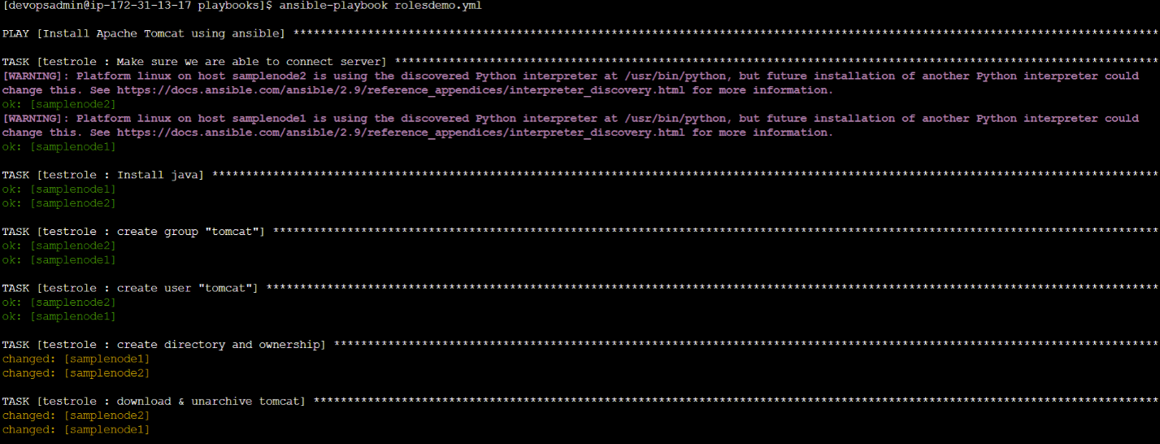

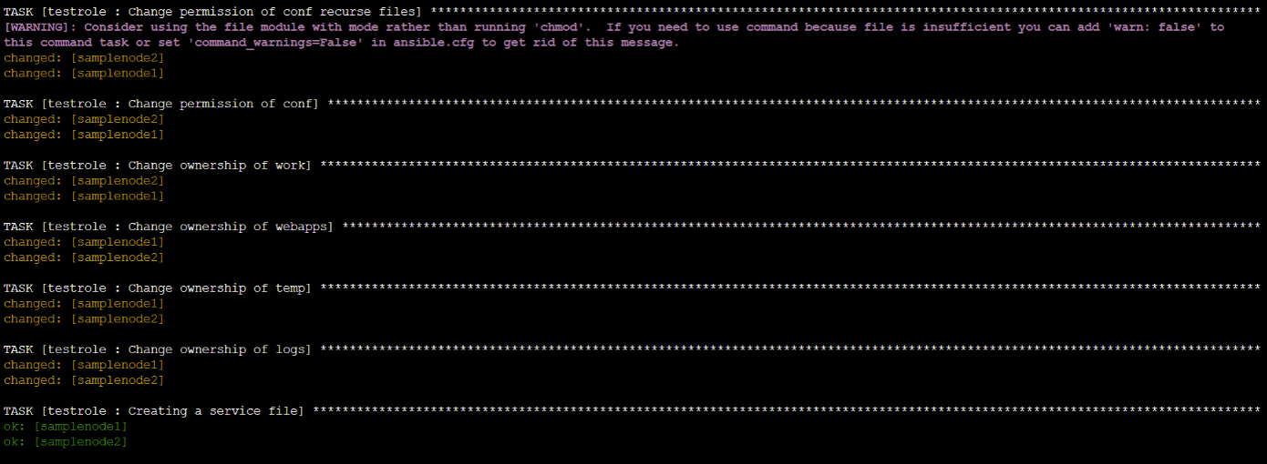

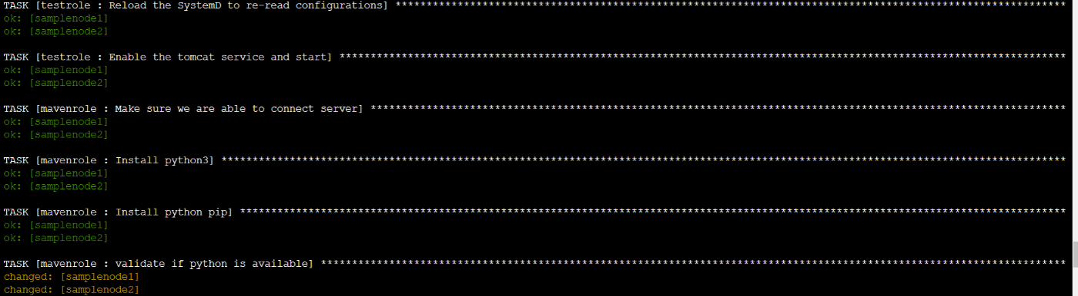

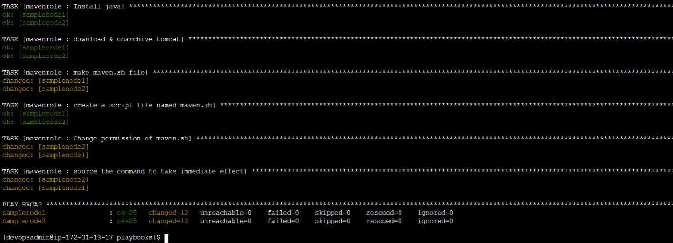

1. Apache tomcat site & Maven is installed on the slave nodes and acceccible now

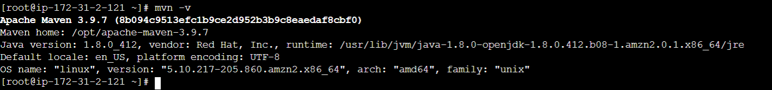

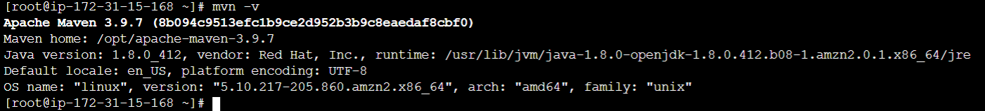

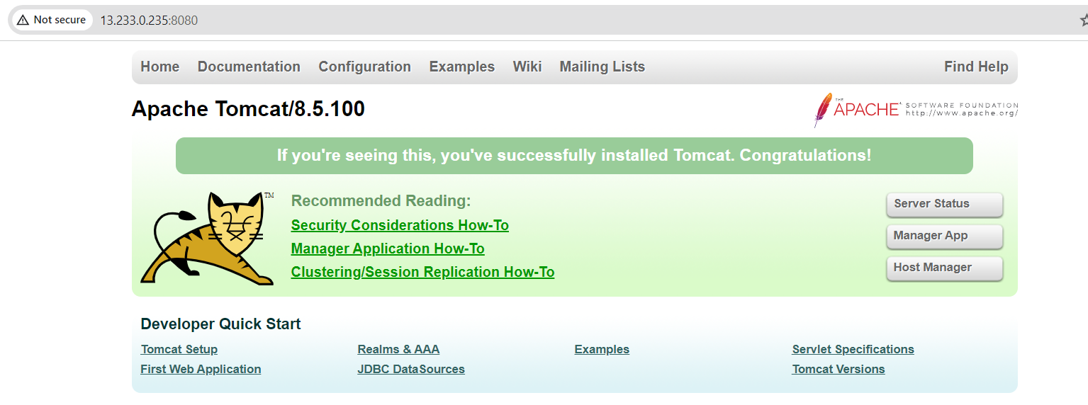

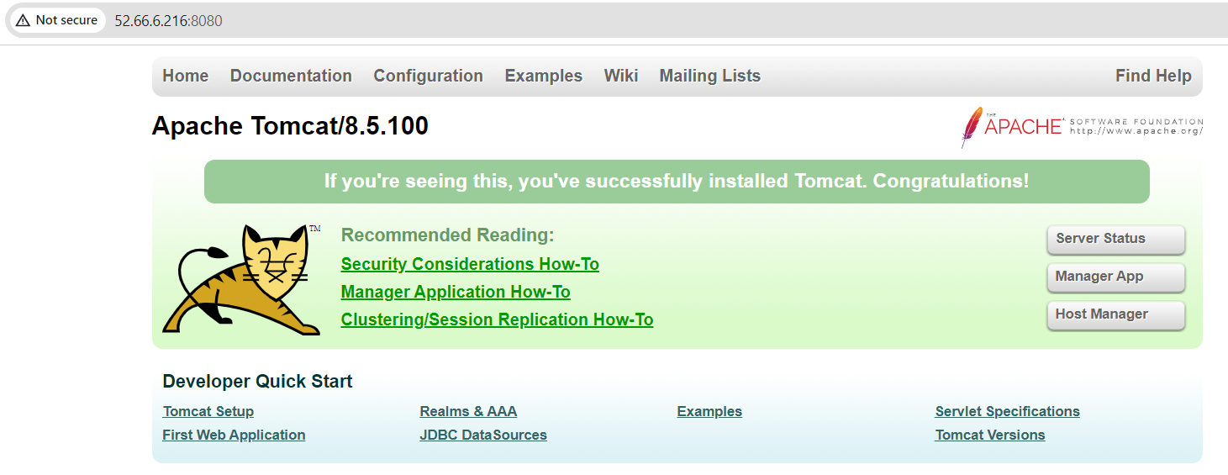

**Outcome:**

* Reduced manual setup time from 45 minutes to under 5 minutes
* Reusable and scalable for deploying across 5+ VMs
* **Maven**: Used in CI/CD pipelines to build apps
* **Tomcat**: Target server where apps are deployed